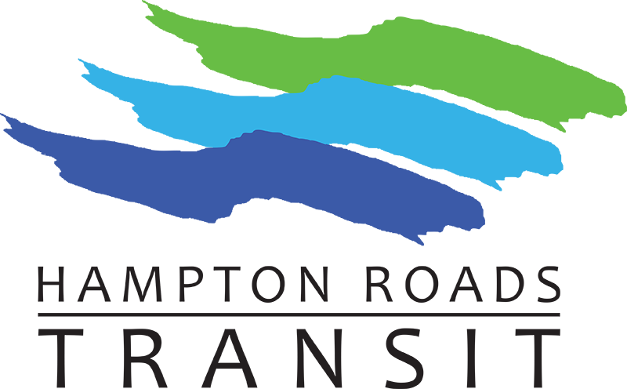
- Call to Order & Roll Call
Meeting of the Transportation District
Commission of Hampton Roads
Thursday, February 24, 2022, • 1:00 p.m.
509 E. 18th Street, Norfolk, VA 23504

Revised Agenda

- Public Comments

- Approval of January 27, 2021, Meeting Minutes

- President’s Monthly Report - William Harrell

- Board Updates

- Committee Reports

- Audit & Budget Review Committee - Commissioner Gray/
Conner Burns, Chief Financial Office

- January 2022 Financial Reports

- Management/Financial Advisory Committee – Commissioner Jackson/
Conner Burns, Chief Financial Officer

- Operations & Oversight Committee - Commissioner Fuller/
Sonya Luther, Director of Procurement

- Contract No: 21-00155 – Federal Legislative Services (Renewal)

Recommending Commission Approval: Award of a contract to Squire Patton Boggs, LLP to provide federal legislative services in the not-to-exceed amount of $234,000 over three (3) years.

- . Contract No: 21-00153 – Fuel Products (Ultra Low Sulfur Diesel
And Gasoline) (Renewal)

Recommending Commission Approval: Award of a contract to James River Solutions to provide fuel products in the estimated amount of $10.1M annually.

- Contract No. 21-00154 – Structured Cabling (Renewal)

Recommending Commission Approval: Award of to Bazon-Cox and Associates, Inc. to provide structured cabling services. The cumulative amount of all Task Orders issued under this contract will not exceed $250,000 over the four-year period.

- Planning/New Starts Development Committee – Commissioner Ross-Hammond/
Ray Amoruso, Chief Planning & Development Officer

- External/Legislative Advisory Committee - Commissioner Kanoyton/
Gene Cavasos, Director of Marketing and Communications

- Smart Cities & Innovation Committee – Commissioner McClellan/
Michael Price, Chief Information/Technology Officer

- Paratransit Advisory Subcommittee – Chair Brian Trickler/
Keith Johnson, Paratransit Services Contract Administrator

- Transit Ridership Advisory Sub-Committee – Ms. Denise Johnson, Chair/
Rodney Davis, Director of Customer Relations

- Old and New Business

- 01– 2022 Resolution – (Recommended by MFAC)
A RESOLUTION TO AMEND THE COST ALLOCATION AGREEMENT BETWEEN THE CITIES OF CHESAPEAKE, HAMPTON, NEWPORT NEWS, NORFOLK, PORTSMOUTH, VIRGINIA BEACH AND THE TRANSPORTATION DISTRICT COMMISSION OF HAMPTON ROADS.

- Comments by Commission Members

- Closed Session (as necessary)

- Adjournment

The next meeting will be held on Thursday, March 24, 2022, 3400 Victoria Boulevard, Hampton, VA 23661

