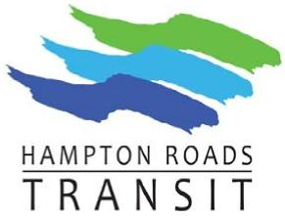 | Management / Financial Advisory Committee Hampton Roads Transit  Monday, November 9, 2020 1:30 p.m. Zoom Teleconference

MFAC Meeting Agenda

- Call to Order
- Roll Call
- Approval of the MFAC Minutes of October 2020
- FY 2021 October Financials – Tabled until December 2020 Meeting
- Old Business:
  - Two Regional Transit Funding Scenarios
  - HRTAC–Update of HRT MOU
  - Calendar – FY 2022 Budget Deveopment
  - CIP Development - Full Presentation
    - CIP CAPEX
    - Other Priorities
  - Regional Transit Transformational Project Implementation Schedule and Resource Allocation Plan
- New Business:
  - Bus Stop App
  - Microtransit Pilot in Virginia Beach and Newport News
  - Multimodal Norfolk and Transit Redesign - Public Outreach Schedule
  - Other Items
- Adjourn

